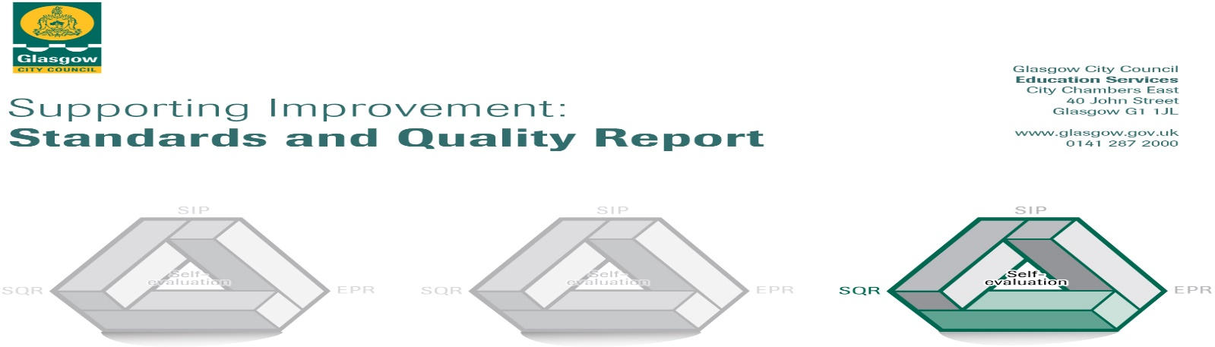

Oakgrove Primary School September 2024

This summary report is provided for parents/careers and partners to outline our achievements in session 2023-24.

Our achievements and improvements this year.

Key developments in Leadership of Change
- An experienced school leadership team continue to provide strong strategic direction ensuring continued school improvements and innovative practice.
- A committed staff who continue to engage in professional learning and leading learning within and beyond the school.
- Our young people leading learning across the school to enhance the learning experience for all.
- An active Parent Council supporting wellbeing of families in the community.

Developments in Learning, Teaching and Assessment
- Our whole school project Home is Here enabled all classes to work with creative partners to explore themes of migration and displacement. Staff led a professional learning event for Glasgow teachers and for Hillhead High School. Education Scotland have documented our work for celebration digitally across Scotland.
Discursive talk, as a focus for school improvement, was integrated into all project plans as children critically considered factors relating to migration.
- All staff explicitly taught and celebrated pupil progress in developing meta skills with reference to developing the young workforce. All staff have become familiar with the My World of Work resource.
- Chat that Counts has been introduced in all classes P 1-7 as a means to develop mental agility in mathematics.
Progress in promoting well-being equality and inclusion

- Our overall average attendance rate was 91.59% which shows an improvement of 0.2%.
- Children from P6 presented a workshop for other children at an anti-racist event in City Chambers. (PARTIE 22)
- Our Young Interpreters offered language support to other children and planned an assembly to celebrate our community languages.
- Our P7 class worked with St Joseph’s Primary on a Sense Over Sectarianism project based on the novel Divided City.
- Our Financial Inclusion Officer attended school workshops/ events and has given direct support to families.
- The Parent Council, mindful of Cost of the School Day guidance, sourced grant funding to support a school events and residential experience.

Progress in children’s learning /raising attainment and recognising achievement
Achievement.

All families had the opportunity to attend monthly Achievement Assemblies. These celebrated achievements in school values, reading, maths, after school clubs, meta skills and other wider school/ individual achievements. These have included the following
- Oakgrove achieved GOLD Reading School status in June 2024 which celebrates our whole school dedication to promoting a reading for enjoyment. The ‘Book Bulbs’ organised book swaps and over 1000 books were exchanged at 3 events across the year. They published a newsletter in June 2024.
- Oakgrove was a runner up school in the Trades House Citizenship Award
- In the Scottish Maths Challenge 2 children were awarded GOLD and 1 child SILVER and were invited to Strathclyde University to celebrate this achievement.
- P5b participates in GCC STARS (Road safety) film project and were awarded a trophy for BEST COSTUMES.
- P5a attended Scottish parliament to showcase their work on Wangari’s Trees to mark World Peace Day. They performed original pieces co created with the Royal Conservatoire of Scotland. A further 5 classes enjoyed an enhanced musical curriculum experience as a result of our RCS partnership.
- P7 participated in a 6-week programme of workshops led by Celtic Connections musicians.
- A P 7/6 attended residential at Blairvadach in May 2024. P6s attended a 6-week programme at Blairvadach (Pinkston Basin).
- Our STEM family learning event was attended by over 100 people. All classes exhibited their STEM work and several stem professionals held workshops. All classes had the experience of working with a STEM professional during curriculum time.
- Primary 6 participated in Clyde in the classroom for the 17th consecutive year.
- 91 children participated in Oakgrove’s Got talent and almost all children participated in our Christmas Show.

Attainment
- Our school serves a transient community and over 70% of our school have English as an Additional Language.
- This table details the percentage of children achieving a level at P1, P4 and P7 in Talking and Listening, Reading, Writing and Numeracy. Our monitoring and tracking systems ensure that all children achieve to their full potential.
 | 20-21 | 21-22 | 22-23 | 23-24
Talking & Listening | 82.8 | 90 | 91 | 87.6
Reading | 62.5 | 76 | 78 | 78
Writing | 63.4 | 71 | 70 | 69.3
Maths | 64.8 | 76 | 76 | 80.3

Here is what we plan to improve next year.
Priorities for development
Further develop our approaches to teaching and learning with a focus on Thinking Routines.
Raise attainment in Writing through developing a consistent methodology P 1-7 in the teaching of sentence structure.
Continue to raise attainment in maths through consolidating Chat that Counts and providing further opportunities for family engagement.

How can you find out more information about our school?
Please contact us directly if you require further information or if you wish to comment on the report.
The contact e-mail address is: Headteacher@oakgrove-pri.glasgow.sch.uk
Our telephone number is: 0141 332 6210
Our school address is: 20, St Peter’s Street, Glasgow. G4 9PW

Further information is available in: newsletters, the school website, Twitter: @OakgrovePri and the school handbook

